**Step1:**

Create .net application

**Step2:**

Login into azure devops with username and password (username must contain subscription)

**Step3:**

Create new project and then repository

**Step4:**

Clone In visual studio

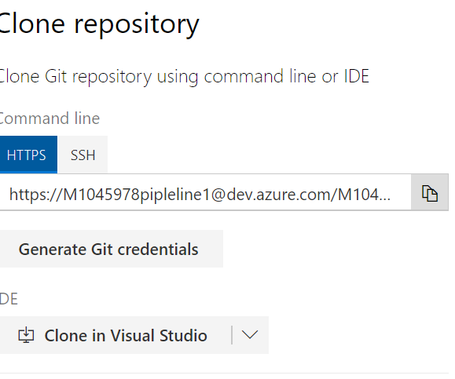

**Step5:**

Create local repository in visual studio and map into azure devops

**Step6:**

Open solution and make some changes then commit, sync finally push into devops repository

**Step7:**

Make sure the changes affected in devops repository

**Step8:**

Create Build definition

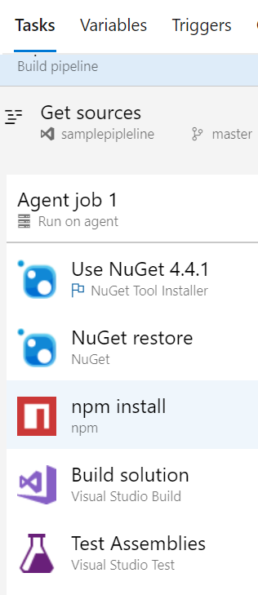

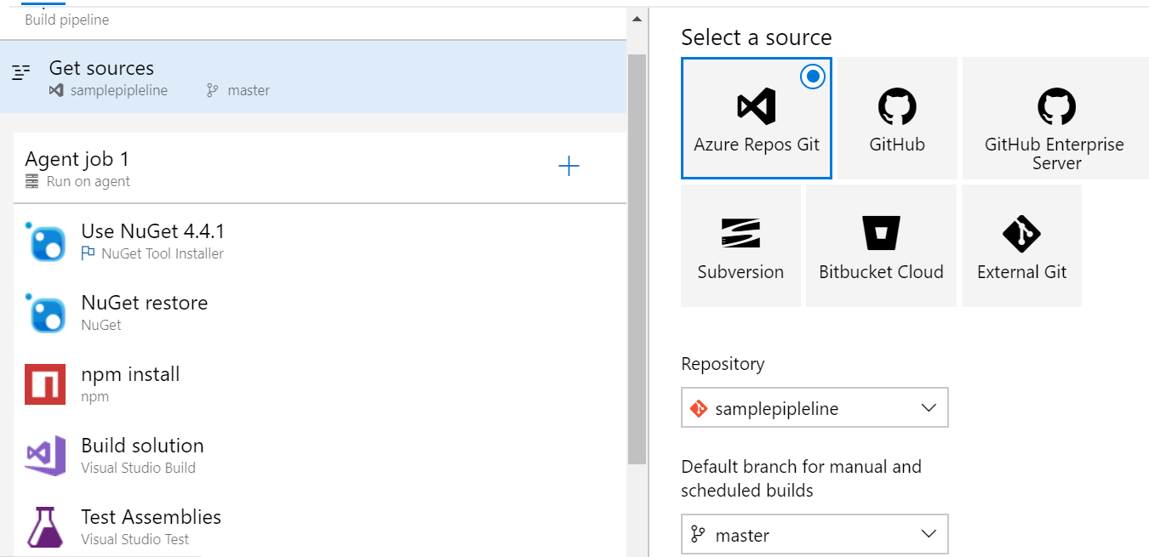

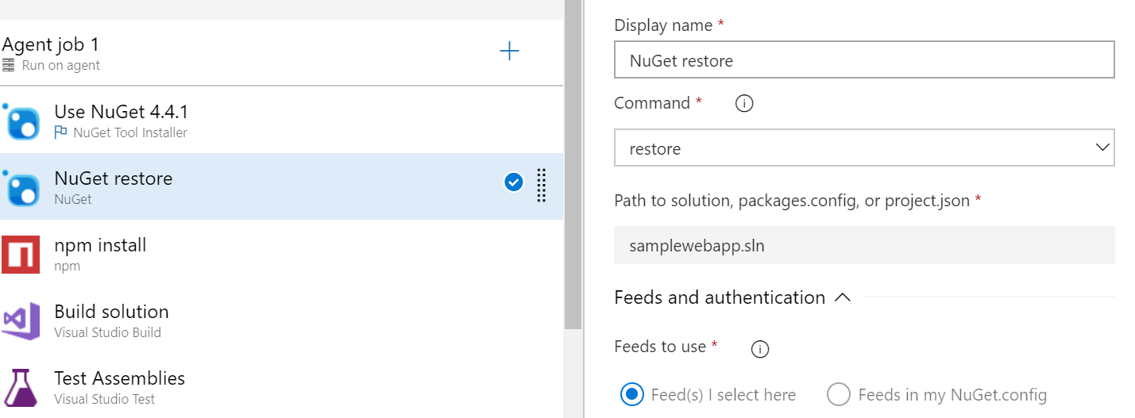

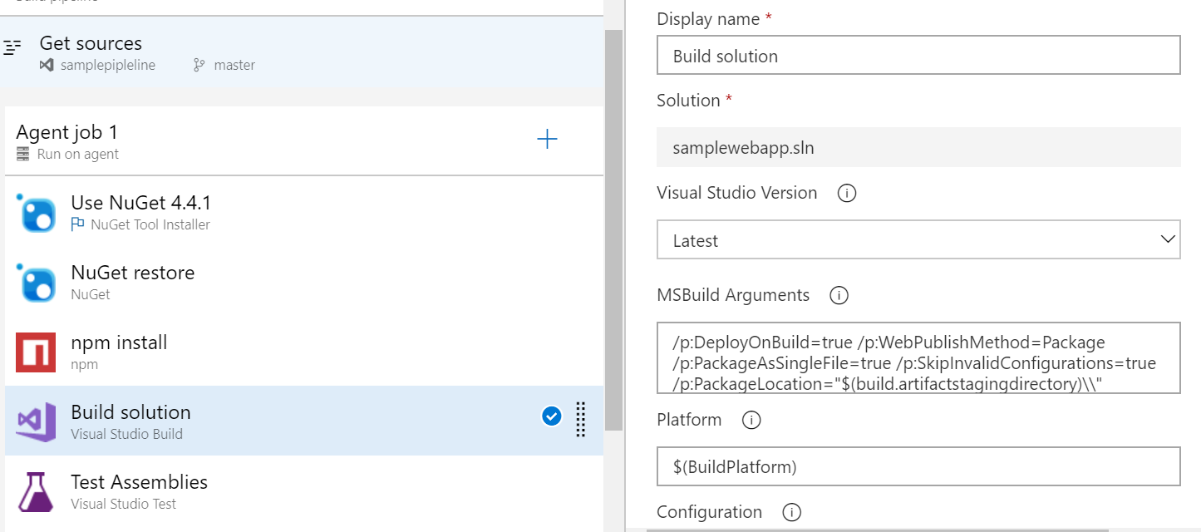

Make sure checked in continuous deployment

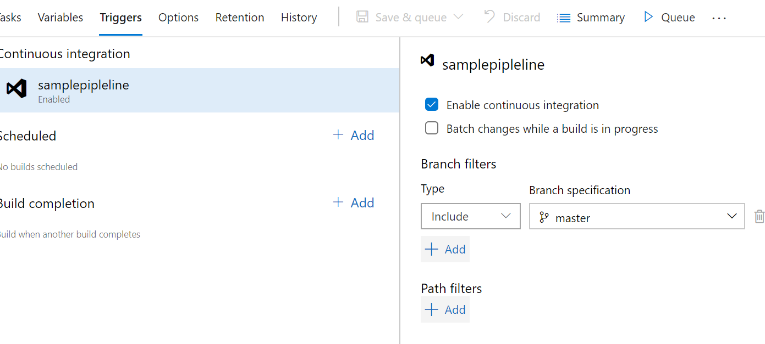Click save and queue

**Step9**:

Create the release pipeline

If you are facing issue while authorize make sure that your subscription id have AD (have subscription)

Create app service in your portal to publish the website

While add the job choose app service deployment

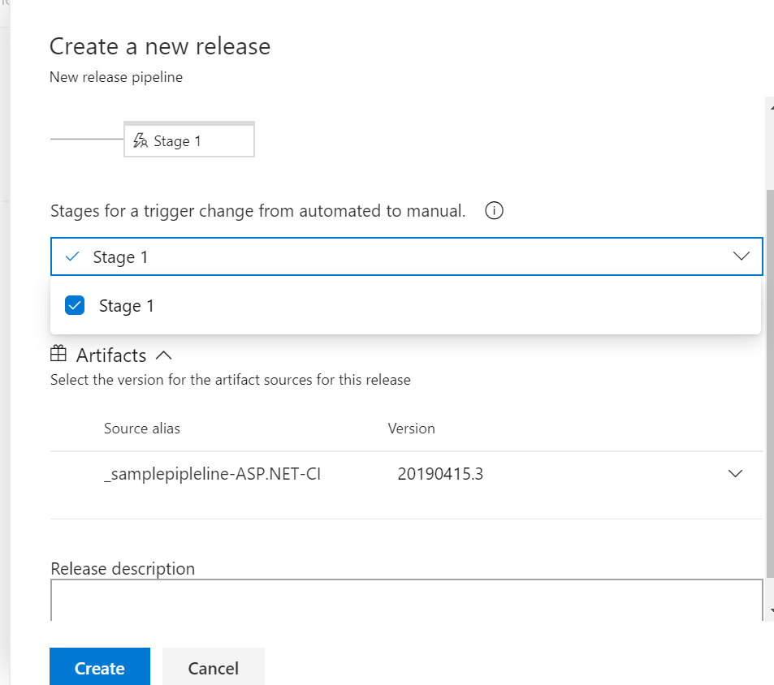

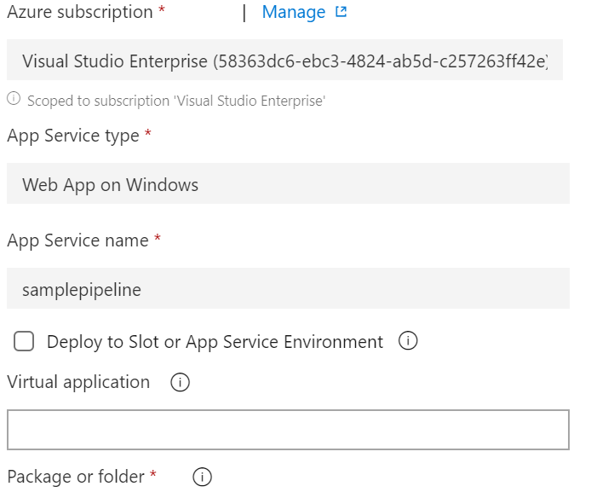

Finally save the release pipeline folder

**Step10**:

Form visual studio commit the code and check in devops build pipeline it will automatically trigger